**Events in JavaScript**

Events in JavaScript are something the browser does make Html elements changed.

Here is a list of some common HTML events:

1. onload
2. onclick
3. ondblclick

**onload event**

This event is used to make specific function after the browser has finished loading the page.

**Example 1:**

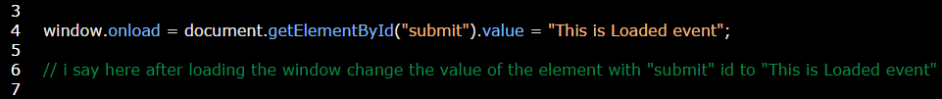

**onclick event**

This event is used to do specific function when the user clicks on an HTML element.

**Example:**



**ondblclick event**

This event is used to do specific function when the user double clicks on an HTML element.

**Example 1:**



**Example 2:**

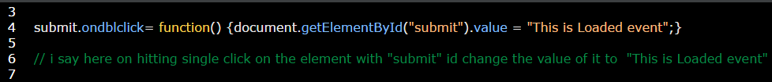

**onkeyup event**

This event is used to do specific function as soon as the user making action.

**Example 1:** in this example the coverage process will occurs as soon as the user (raise his hand up the number in keyword) writing the number automatically without needing to press buttons.

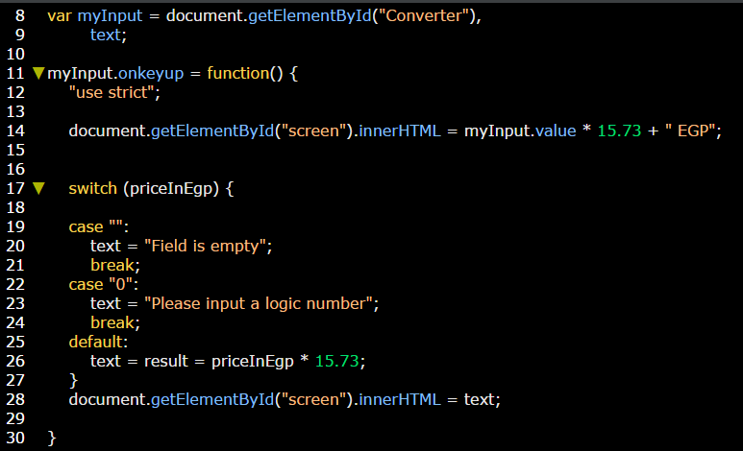

**onkeydown event**

This event is used to do specific function after pressing another key in your keyboard.

**Example:**

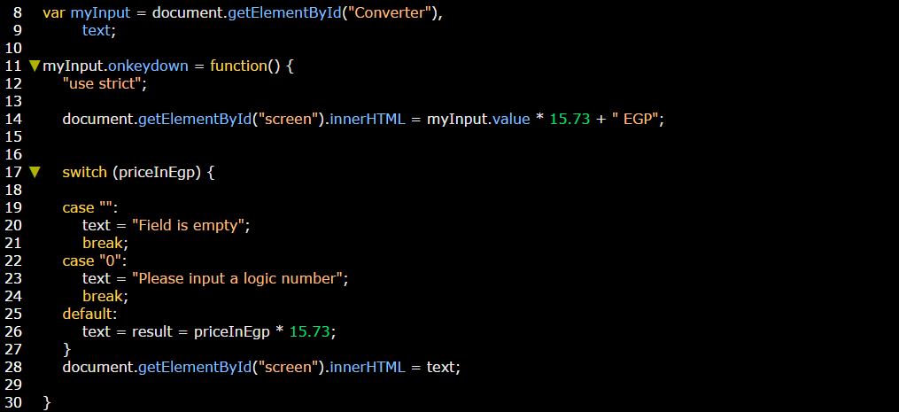

**onkeypress event**

This event is used to do specific function after pressing another key in your keyboard.

**Example:**

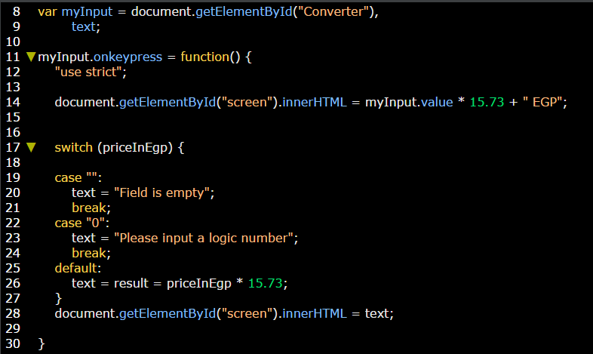

**onmouseover event**

This event is used to do specific function on hovering over specific html element.

**Example:**

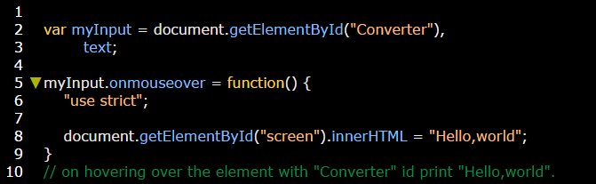

**onmouseout event**

This event is used to do specific function on leaving mouse out a specific html element.

**Example:**

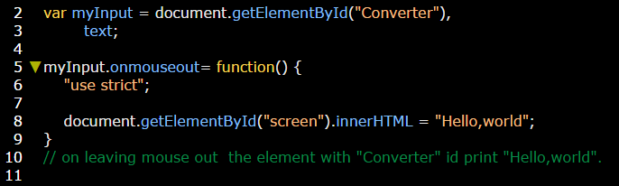

**onchange event**

This event is used to do specific function when occurring specific change to an html element.

**Example 1:**

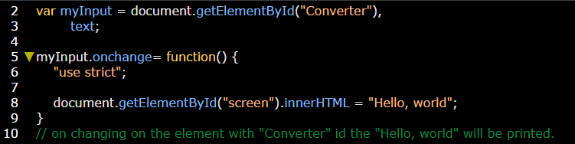

**Example 2:**

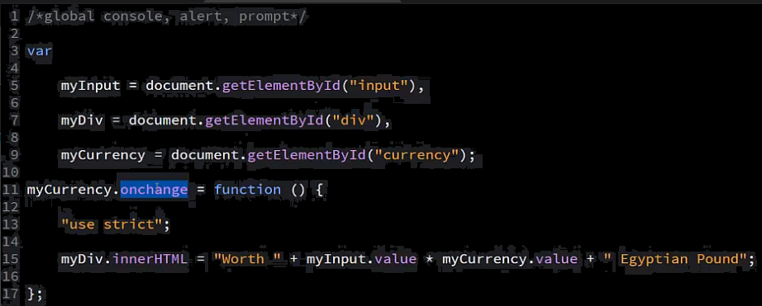

**Note:** You can do more than one event on the same element.

**Example:**

